1. A close up of a sign

   Description automatically generated
2. 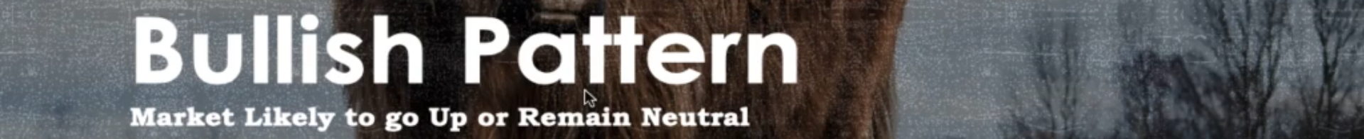
3. A close up of a pattern

   Description automatically generated
4. A diagram of a candle stick graph

   Description automatically generated
5. A graph with a red arrow

   Description automatically generated